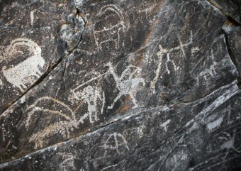 | 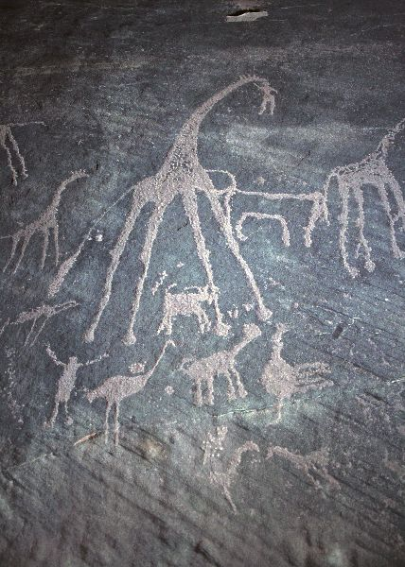 | 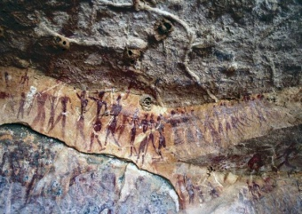 | 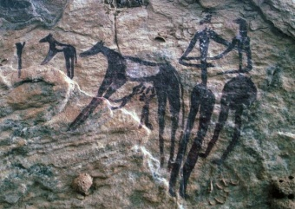
1. Wadi Hammamat, Eastern desert, Egypt. Hunter, goats and ostriches. Bubalus Period. 12000 – 8000 yrs BP. | 2. Karkur Talh, Jebel Uweinat, Sudan. Giraffes and ostriches. Bubalus Period. 12000 – 8000 yrs BP. | 3. Karkur Talh, Jebel Uweinat, Sudan. Procession. Early Nomadic period. 7000 – 6000 yrs BP. | 4. Karkur Talh, Jebel Uweinat, Sudan. Practical milk delivery or an African equivalent of the tale of Romulus and Remus. Early Nomadic period. 7000 – 6000 yrs BP.
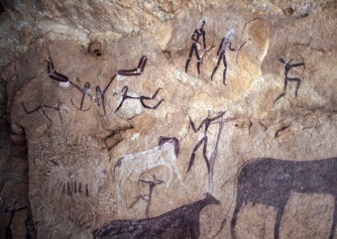 | 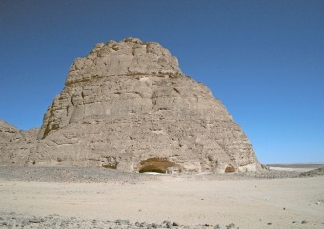 | 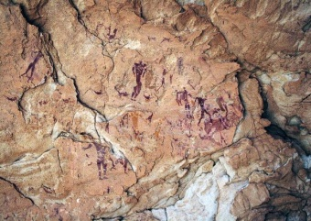 | 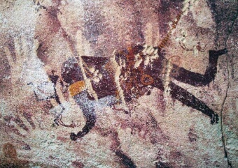
5. Karkur Talh, Jebel Uweinat, Sudan. Defending cattle from a lion attack. Nomadic period. 7000 – 5000 yrs BP. | 6. Wadi Sora, Gilf Kebir, Egypt. The Cave of Swimmers, found by a Hungarian soldier, adventurer and archaeologist in 1933. Famous for depictions of swimming humans and headless animals. | 7. Wadi Sora, Gilf Kebir, Egypt. Swimmers, decorated humans and a headless animal. | 8. Foggini-Mestekawi, Gilf Kebir, Egypt. This cave was discovered in 2003. It is famous for its hundreds of palm prints. A mythical headless animal figure is presented here.
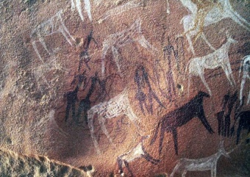 | 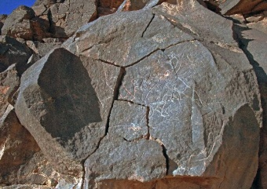 | 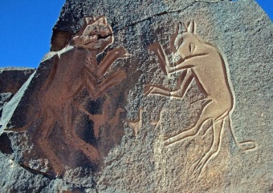 | 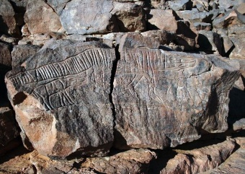
9. Gilf Kebir, Egypt. Headless bovines and herdsmen. Nomadic period. 7000 – 5000 yrs BP. | 10. Madi Mathkendoush, Messak Settafet, Libya. Rhino catchers. Fox-headed people have managed to hunt down a rhinoceros. Bubalus Period. 12000 – 8000 yrs BP. | 11. Wadi Mathkendoush, Messak Settafet, Libya. The fighting cats. The rock is starting to crack badly. Height of the cats is about 1 meter. Bubalus Period. 12000 – 8000 yrs BP. | 12. Wadi Mathkendoush, Messak Settafet, Libya. Crocodile and its baby. The length of the crocodile is about 2,2 meters. This rock is also cracked. Bubalus Period. 12000 – 8000 yrs BP.
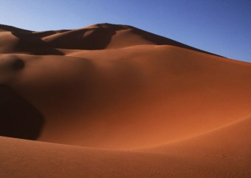 | 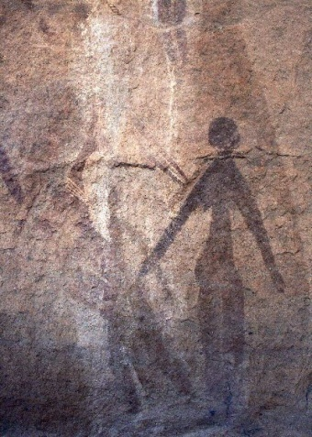 | 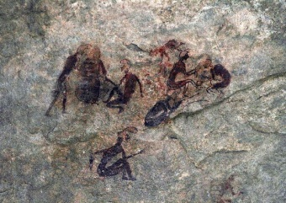 | 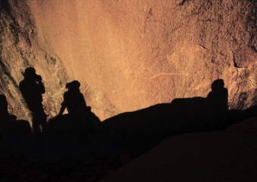
13. Dunes of Wan Caza between Messak Settafet and Acacus. | 14. Wadi Tanshal, Acacus, Libya. Dancers from the Round Head period. Part of a painting 1,5 meters wide and 2 meters tall. 10000-8000 yrs BP. | 15. Wadi Tashwinat, Acacus, Libya. Famous depiction of a wedding ceremony. Nomadic period. 7000 – 5000 yrs BP. | 16. Tin Mgharen, Tassili n’Ajjer, Algeria. Drawing of a buffalo. Bubalus Period. 12000 – 8000 yrs BP.
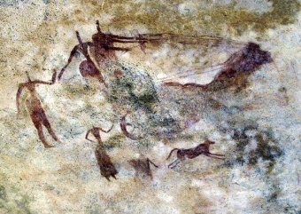 | 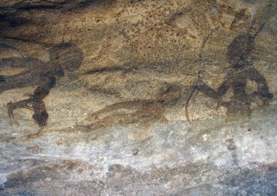 | 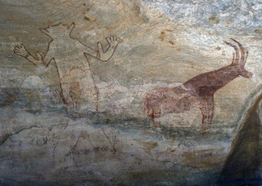 | 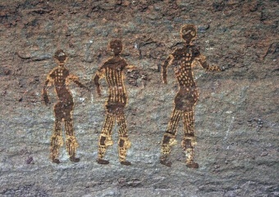
17. Tin Aboteka, Tassili n’Ajjer, Algeria. A couple in a carriage pulled by three horses. Horse and carriage period. 3000 – 2000 yrs BP. | 18. Tin Tazarift, Tassili n’Ajjer, Algeria. Hunters from the Round Head period, about 1,5 meters tall. 10000-8000 yrs BP. | 19. Sefar, Tassili n’Ajjer, Algeria. The famous god of Sefar. About 2,5 meters tall. This deity being worshipped seems to suffer from elephantiasis. Round Head period. 10000 – 8000 yrs BP. | 20. Sefar, Tassili n’Ajjer, Algeria. Female dancers covered with bodypaintings or clothes. Height about 1 meter. Round Head period. 10000 – 8000 yrs BP.
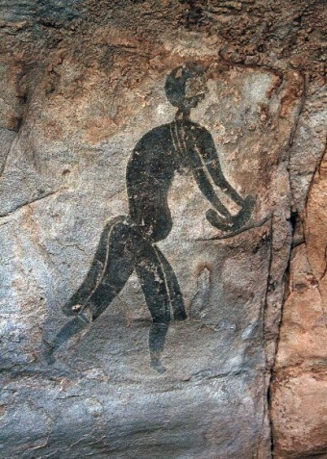 | 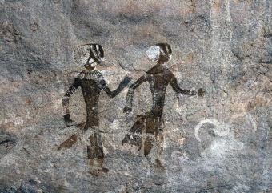 | 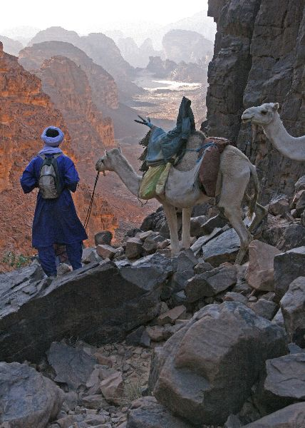 | 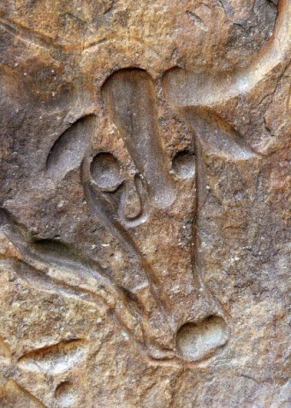
21. Sefar, Tassili n’Ajjer, Algeria. A painting known as The Black Lady. Round Head period. 10000 – 8000 yrs BP. | 22. Tan Zoumaitak, Tassili n’Ajjer, Algeria. A dancing couple surrounded by goats. Round Head period. 10000 – 8000 yrs BP. | 23. Descent from the upper plateau of Tassili n’Ajjer to a valley 700 meters below. | 24. Tegahahart. The most famous of Sahara's petroglyphs, The Weeping Cow can be found along the road leading to Djanet airport. length of head without horns about 50 cm.  Nomadic period. 7000 – 5000 yrs BP.

